EXECUTIVE SUMMARY

Overview
This project was about using Group Policy settings on a Windows 11 computer to improve security and control what users can access. I used the Local Group Policy Editor to apply important rules, like locking an account after failed logins and limiting access to just one part of the Control Panel. I tested everything using a virtual machine and saved screenshots as proof.

The Problem
Sometimes, standard users (non-admins) can try to change important settings or guess passwords, which can be risky.
The problem: Computers without proper settings can be misused or attacked.
Who it affects: Admins who manage computers that are shared, like in schools or labs.
Current solutions: Some people don’t know about Group Policy or don’t use it well.

The Solution
I used Group Policy to fix these problems.
I set the computer to lock an account for 3 minutes after 3 wrong password attempts.
I also made it so users can only see the Network and Sharing Center in the Control Panel.
I created a standard user called "Project5" and tested the settings. This solution is not hard once you learn how to use the Group Policy Editor and MMC tool.

Highlights
I finished all the steps, tested them, and everything worked.
I used a standard user account to check if the settings were correct.
I learned how to apply rules to all users and then how to limit rules to just one user using a custom policy saved through MMC.
The best part: I now understand how to manage Windows settings better.

Screenshot 1: Control Panel showing only Network and Sharing Center

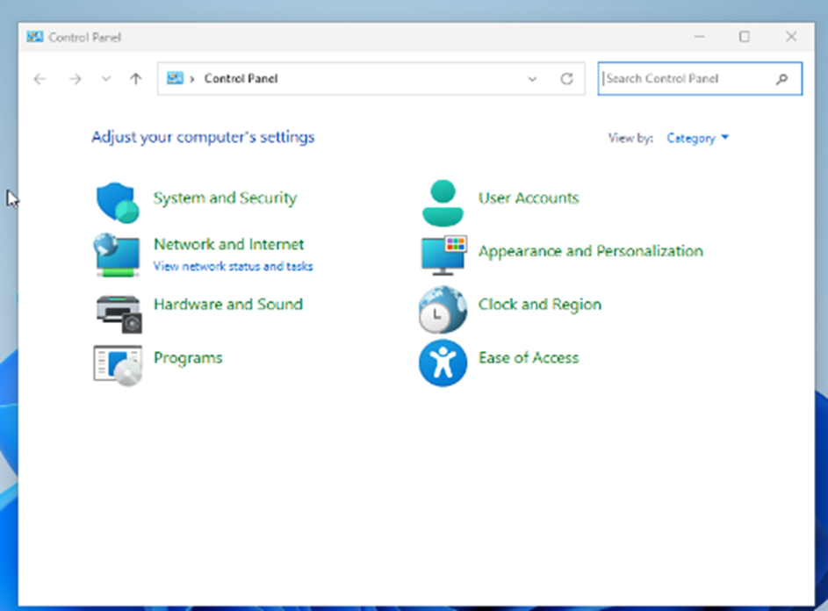

Screenshot 2: Account locked after failed logins

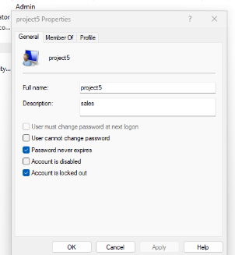

Screenshot 3: Custom policy icon saved on desktop

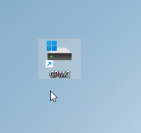

Keys to Success
I followed all the steps, like creating a new user, setting lockout rules, and limiting access to Control Panel.
I needed a computer with Windows 11 Pro (or a VM), admin access, and some time to test.
It took me about 1 hour to finish everything and fix small issues.
Financial Highlights This project didn’t involve money, but using Group Policy can help schools or companies save time and money by preventing users from breaking things or causing issues.

Financial Highlights
This project didn’t involve money, but using Group Policy can help schools or companies save time and money by preventing users from breaking things or causing issues.

